User Management Functional Requirements

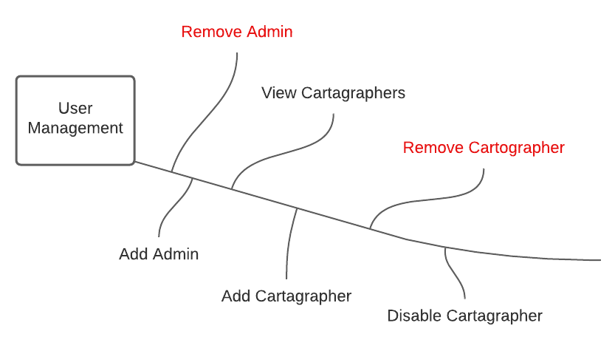

# Functional Requirements

1. The system shall always have at least one Admin.
2. The system will not allow the last Admin to be removed.
3. The system will allow Admins to add new Cartographers.
4. The system shall transfer ownership of charts and regions to specified user upon removal of their owner.
5. The user management system will allow Admins to add additional Admins.
6. The user management system will all